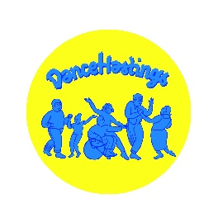
DANCE HASTINGS Volunteer REGISTRATION Form
Full Name

Postcode |  | Phone
Email
Do you have any of the below:

Up-to-date DBS [please give date and number]
Registered for the DBS update service [please give number]
First aid certificate [please give details and date
Certificate of participation in safeguarding training
Any other relevant experience or training [please give details]

What volunteering roles are you interested in?

Dance Buddy/ Trustee

Self declaration
- Have you ever been cautioned or convicted of any criminal offences? Yes/No? If yes, please provide full details.

Note: You are advised under the provisions of the Rehabilitation of Offenders Act 1974 (Exceptions) order 1975 as amended by the Rehabilitation of Offenders Act 1974 (Exceptions Amendment) order 1986 you should declare all convictions, including spent convictions.
- Are you a person known to any social services department as being an actual or potential risk to children and/or vulnerable adults? Yes/No?
If yes, please provide full details.

- Have you had a disciplinary sanction (from a sports provider or organisation or governing body)? Yes/No?
If yes, please provide full details below.

4. Declaration

I have read and understood the Dance Hastings Safeguarding and Data Protection policies. I hereby consent to Dance Hastings undertaking DBS, Police and/or Social Services checks against me. I understand that the information contained on this form, the results of checks and information supplied by third parties, will be held by Dance Hastings.

I am aware that failure to declare any existing or future concerns or convictions which are relevant in relation to assessing my suitability to work with children will result in suspension of duties pending investigation.

I give my permission for my phone number to be included in What’s App groups of volunteers for the sessions I am interested in supporting, as the most efficient means of communication for the dance facilitators
YES/NO

Signed____________________ Date_________

Please return to dancehastings@gmail.com

